Task 8 : Auto Scaling Groups
1. Launch EC2 Instance and Host Static Website
- Open AWS Console → EC2 → Launch Instance.
- Select Amazon Linux 2 AMI and t2.micro.
- Allow HTTP (80) and SSH (22).
- Connect using SSH.
- Install Apache:
sudo yum update -y
sudo yum install httpd -y
sudo systemctl start httpd
sudo systemctl enable httpd
- Create /var/www/html/index.html and browse using the instance public IP.
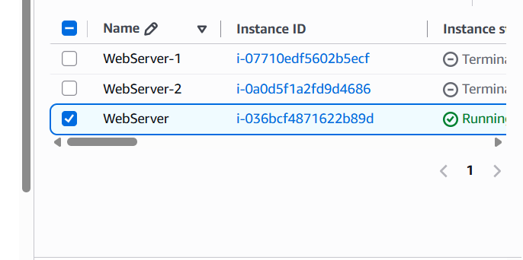
Connected to ssh
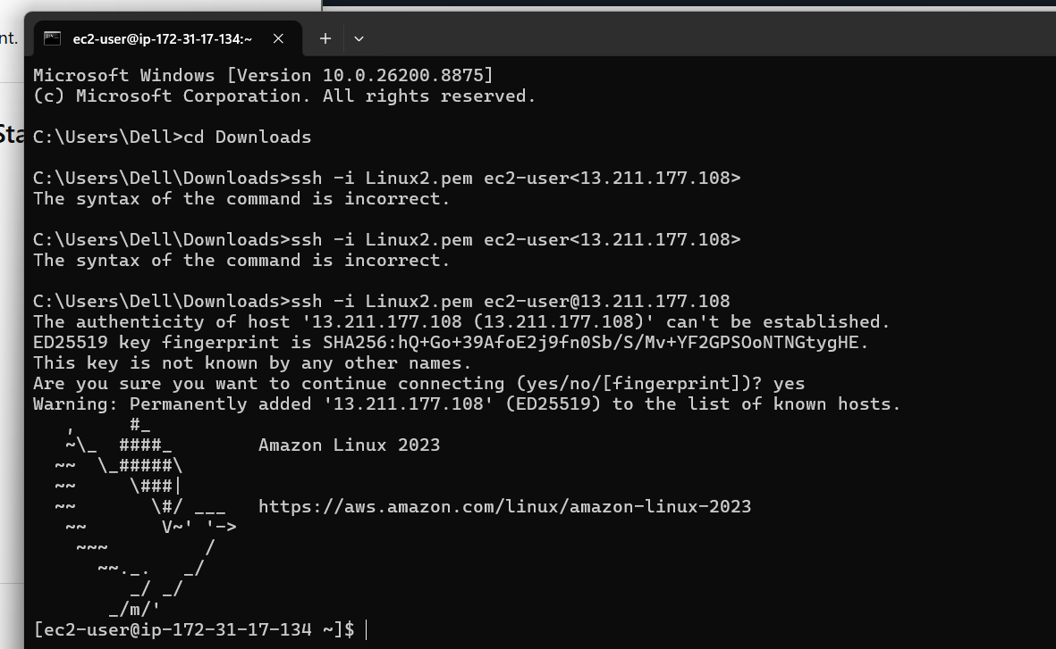
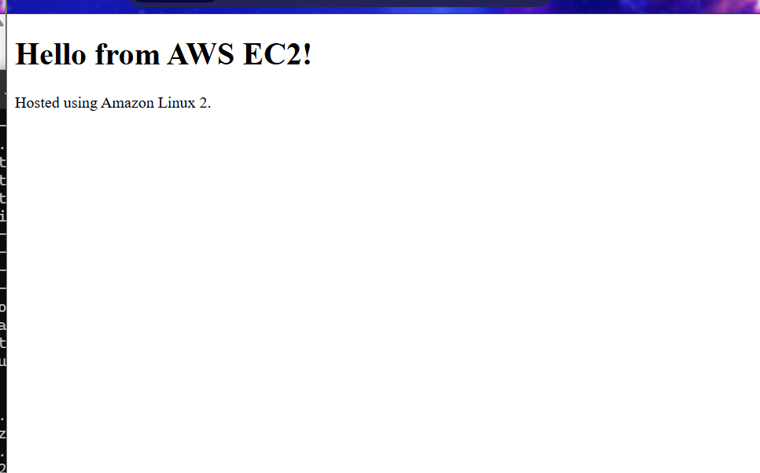

2. Create an Auto Scaling Group
- Create a Launch Template using the EC2 configuration.
- Add User Data to install Apache automatically.
- Create an Auto Scaling Group using the Launch Template.
- Select your VPC and public subnets.
- Set Desired Capacity = 1, Minimum = 1, Maximum = 3.
- Configure Target Tracking Scaling Policy with Average CPU Utilization = 60%.
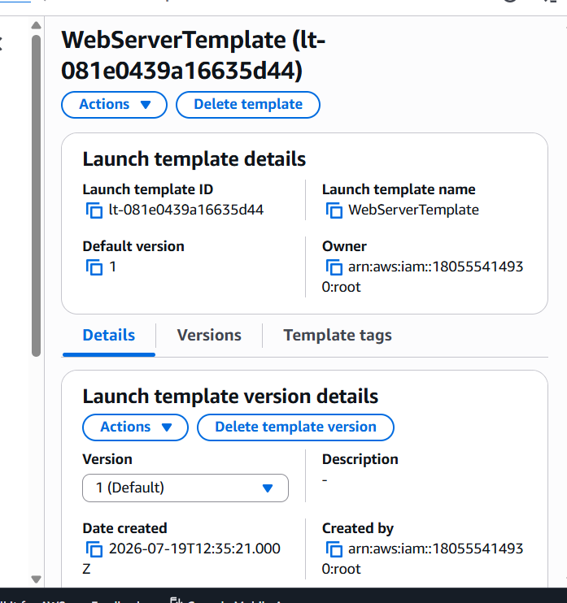
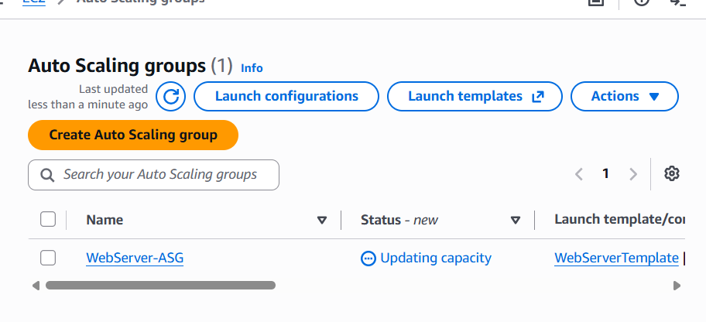

3. Simulate Load
Use Loader.io or k6 to generate HTTP traffic to the Load Balancer DNS or EC2 instance. Observe additional EC2 instances launching when CPU exceeds the threshold.
import http from 'k6/http';
export default function () {
http.get('http://YOUR-LOAD-BALANCER-DNS');
}
k6 run load-test.js

4. Verify Scale In
Stop the load test. Verify that the Auto Scaling Group terminates extra instances and returns to one running instance. Capture screenshots of the Activity History and EC2 Instances page.
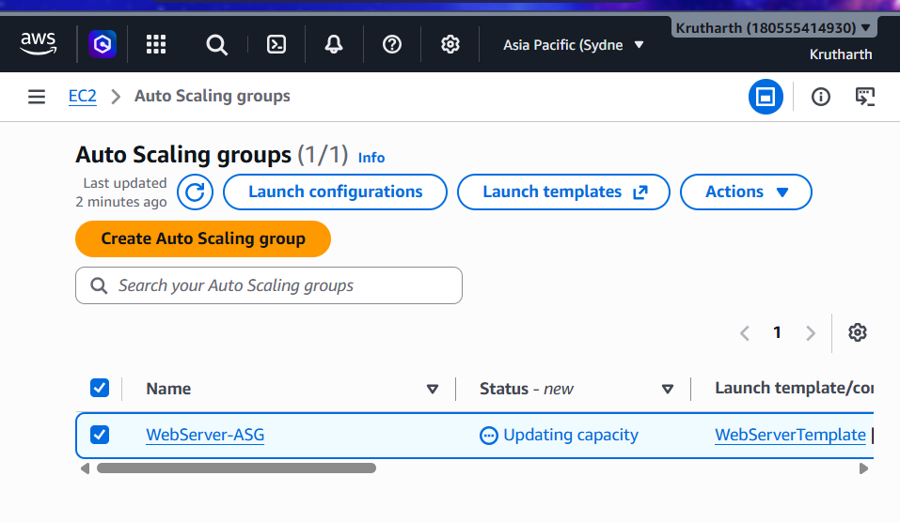
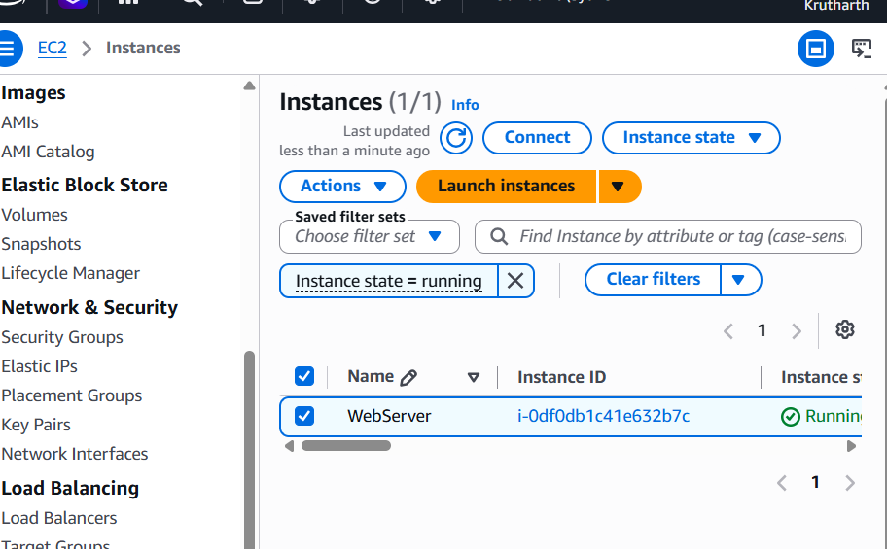

5. Real-world Examples
Application | Scenario | Why Auto Scaling Helps
Zomato | Lunch and dinner hours generate many food orders. | Auto Scaling launches additional servers to handle increased traffic and maintain fast response times.
Flipkart | During sales such as Big Billion Days, millions of customers visit simultaneously. | Auto Scaling increases server capacity to prevent slowdowns or crashes and reduces resources afterward to save costs.
BookMyShow | Ticket bookings surge when a popular movie or concert goes live. | Auto Scaling adds servers to process booking requests quickly and scales down once demand decreases, ensuring reliable service.

